EXPERIMENT NO-12 :TIC TAC TOE GAME
Aim
To implement a Tic-Tac-Toe game using Prolog, where two players take turns placing X and O on a 3×3 board.
Algorithm
- Create a 3×3 Tic-Tac-Toe board using nine positions.
- Initialize all positions as empty.
- Display the board.
- Ask the current player to select an empty position.
- Place the player's symbol (x or o) in that position.
- Check whether the player has three symbols in a row, column, or diagonal.
- If a player wins, display the winner and stop.
- If all positions are filled, declare a draw.
- Otherwise, switch the player and repeat the process.
Python Code
# Tic-Tac-Toe Game

board = [' ' for _ in range(9)]

def display_board():
print()
print(board[0], '|', board[1], '|', board[2])
print('--+---+--')
print(board[3], '|', board[4], '|', board[5])
print('--+---+--')
print(board[6], '|', board[7], '|', board[8])
print()

def check_winner(player):
winning_positions = [
(0, 1, 2),
(3, 4, 5),
(6, 7, 8),
(0, 3, 6),
(1, 4, 7),
(2, 5, 8),
(0, 4, 8),
(2, 4, 6)
]

for a, b, c in winning_positions:
if board[a] == board[b] == board[c] == player:
return True

return False

def check_draw():
return ' ' not in board

# Main game
player = 'X'

print("TIC-TAC-TOE")
print("Positions are numbered from 1 to 9.")

while True:
display_board()

try:
position = int(input("Player " + player + ", enter position (1-9): "))
except ValueError:
print("Please enter a number.")
continue

if position < 1 or position > 9:
print("Enter a position between 1 and 9.")
continue

if board[position - 1] != ' ':
print("Position already occupied. Try again.")
continue

board[position - 1] = player

if check_winner(player):
display_board()
print("Player", player, "wins!")
break

if check_draw():
display_board()
print("It's a draw!")
break

# Change player
if player == 'X':
player = 'O'
else:
player = 'X'
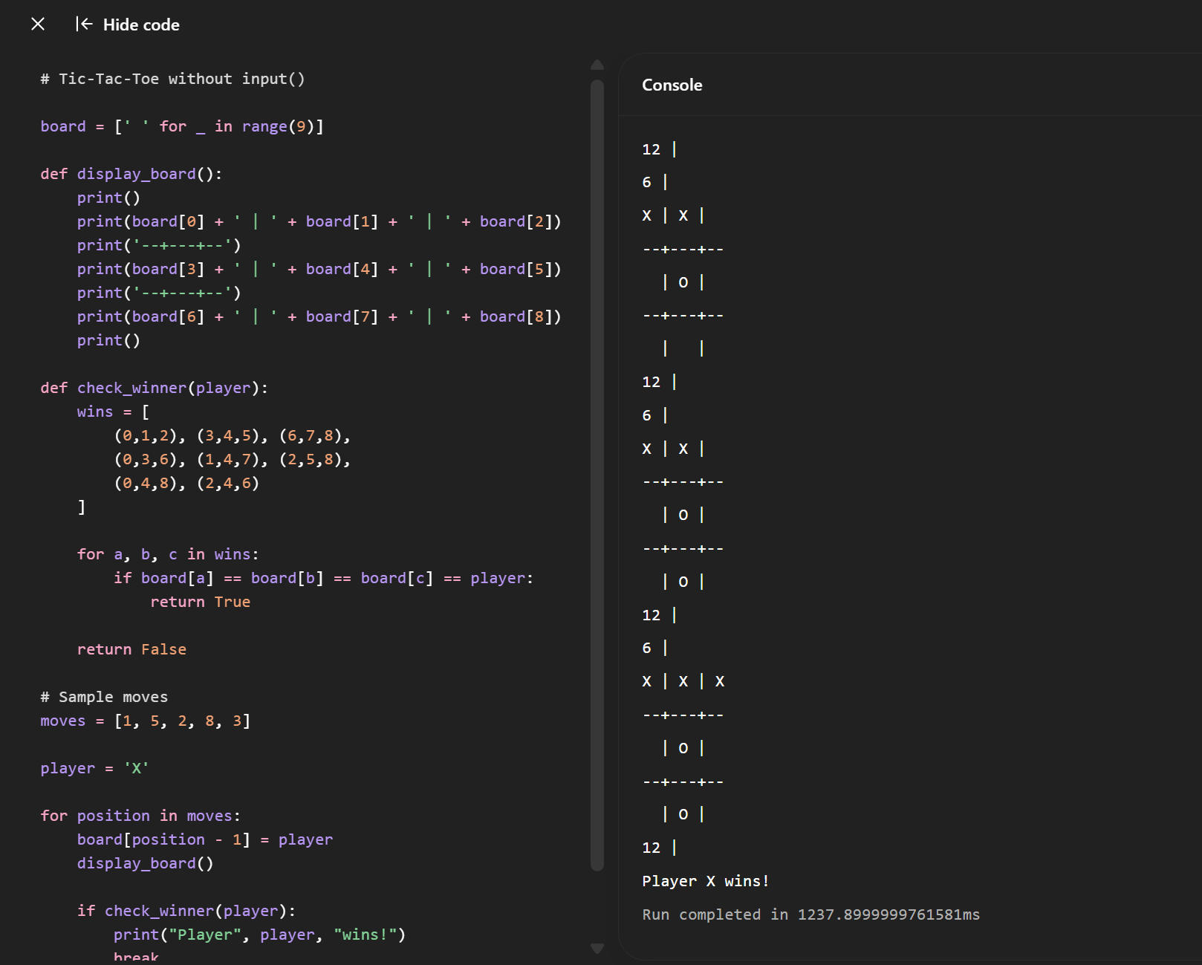
Result
Thus, the Tic-Tac-Toe game was successfully implemented in Prolog, allowing two players to play alternately and automatically detecting wins and draws.

